ICS4U Unit 1 Test

|  |  |  |  |
| --- | --- | --- | --- |
| K: 9 /10 | T: 9/10 | C: 5/5 | A: 5/5 |

Answer the following multiple-choice questions (10 K)

1. Find the output

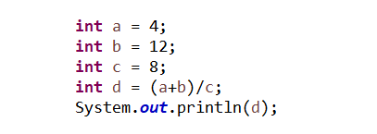

* 1. 24
  2. 2
  3. 12
  4. 20

Choice: ____b______

1. Find the output

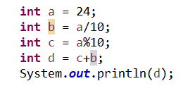

* 1. 24
  2. 42
  3. 8
  4. 6

Choice: _____d_____

1. Find the output



1. Bob is 25 years old
2. Bob is 7 years old
3. Bob is 2 years old
4. Bob is 5 years old

Choice: _____a_____

1. Find the output

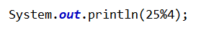

1. 6
2. 1
3. 6.25
4. 29

Choice: _____b_____

1. Find the output



1. 6
2. 1
3. 6.25
4. 29

Choice: _____b_____

1. Which of these is a legal variable name?
2. 3Cars
3. #ofCars
4. cars
5. num of cars

Choice: _____c_____

1. Find the output



1. 5
2. 20
3. 3922
4. Error

Choice: ____b______

1. Find the output



1. She said I love dogs.
2. She said “I love dogs.”
3. I love dogs.
4. She said “I Love Dogs.”

Choice: _____b_____

1. Identify the incorrect way(s) of finding the square for a number in the following program

Int x = 23;

1. System.***out***.println(x*x);
2. System.***out***.println(Math.*pow*(x, 2));
3. System.***out***.println(Math.*exp*(x, 2));
4. System.***out***.println(Math.*multiplyExact*(x, x));

Choice: _____c_____

1. Find the output

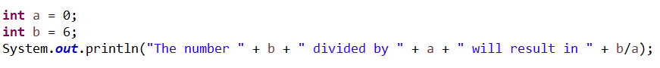

1. String “infinity”
2. String “-infinity
3. NaN
4. Exception, program will exit

Choice: _____c_____

Identify the error and error type and explain how the code would be fixed (10 T)

**double** 1num = 0, 2num = 0, 3num = 0;

**int** average = 0;

Scanner userInput = **new** Scanner(System.in);

System.out.println("Enter three real numbers to find out their average.");

1num = userInput.nextLine();

2num = userInput.nextLine();

3num = userInput.nextLine();

average = 1num + 2num + 3num / 3;

System.out.println("The average of the three numbers is: " average);

This is a syntax error because we cannot even try to execute the program. To fix this error, we need to numbers in front of the double variables ‘1num’, ‘2num’, ‘3num’ have to be at the end. Therefore, we need to fix them into ‘num1’, ‘num2’, ‘num3’.

2



**public** **static** **int** countArray(**int**[] array) {

**int** total = 0;

**for** (**int** i = 1; i < array.length; i++) {

total += array[i];

}

**return** total;

}

**public** **static** **void** main(String[] args) {

// **TODO** Auto-generated method stub

**int**[] array = { 1, 2, 3 };

**int** total = *countArray*(array);

System.***out***.println("The total is: " + total);

}

This is a logic error because the output is not what we are looking for. The output of this code is 5, but the output has to be 6, not 5. To fix this error, we need to change integer variable i into 0, not 1. Because the index number starts from 0, we need to count the number from 0.

2



**int** var1 = 15;

**int** var2 = 5;

**int** var3 = 0;

**int** ans1 = var1 / var2;

**int** ans2 = var1 / var3;

System.***out***.println("Division of va1" + " by var2 is: " + ans1);

System.***out***.println("Division of va1" + " by var3 is: " + ans2);

This is a runtime error because there is an error while the program is running. To fix this error, either variable ‘var3’ or the variable ‘ans2’ has to be changed. Because it is impossible to divide numbers by zero, the error occurs while the program is running. 2



System.out.println("Multiplication Table of 7");

**int** a = 7, ans;

**int** i;

// Should have been

// for(i=1; i<=10; i++)

**for** (i = 1, i <= 10; i++) {

ans = a * i;

System.out.println(ans + "\n");

}

This is a syntax error because we cannot even try to execute the program. To fix this error, we need to change the comma to semicolon between i=1 and i<= 10 in the for loop.

2



**public** **static** String rotate(String direction) {

**if** (direction.equals("up")) {

direction = "right";

}

**if** (direction.equals("right")) {

direction = "down";

}

**if** (direction.equals("down")) {

direction = "left";

}

**if** (direction.equals("left")) {

direction = "up";

}

**return** direction;

}

**public** **static** **void** main(String[] args) {

String direction = "up";

direction = *rotate*(direction);

direction = *rotate*(direction);

System.***out***.println("Direction: " + direction);

}

This is a logic error

1

No solution

Choose two from the following challenges then construct the requested code with commenting. (10 C, 10 A) Include a screenshot of the completed program.

1. Write a program that prompts the user for two numbers, being the numerator and denominator of the fraction. It should output the fraction, then if it is an improper fraction, it should output the result, then the result as a mixed fraction. For example, if the input is 7 and 4, the output should be 7/4 is equal to 1 ¾. Also make sure to put in a stop if the calculation would be impossible.



1. Write a program that will ask for 10 numbers, then identifies whether or not each number is a prime number. Then at the end, it will output the list of all of the prime numbers that were inputted



1. Write a code in java that asks the user how many kids there are in each class: A, B, C. The students need to be in groups of ten. How many groups of ten can be made either within each class on their own or with the total amount of kids attending? How many kids will be leftover for a final group? In each scenario. For example, if for the A, B, and C I input 24, 31, 25. My output should show that for class A I can get 2 groups with 4 leftover students, class B I can get 3 groups with 1 leftover students, class C I can get 2 groups with 5 leftover students, and all together, I can get 8 groups with 0 leftover students.



5 C 5A